Ques1: Write a JAVA program to implement class mechanism. – Create a class (Student), define data members (Roll_no, name, marks), constructor, methods (setData(args), getData()) and invoke them inside main method.

Source Code

**package** Lab4;

**class** Student

{

**int** rollno;

String name;

**float** marks;

Student(){

System.***out***.println("This is student class constructor");

}

**void** setData(**int** r,String n,**float** m) {

**this**.rollno = r;

**this**.name = n;

**this**.marks = m;

}

**int** getrollno() {

**return** **this**.rollno;

}

String getname() {

**return** **this**.name;

}

**float** getmarks() {

**return** **this**.marks;

}

}

**public** **class** StudentClass {

**public** **static** **void** main(String args[]) {

System.***out***.println("Hitendra Sisodia");

System.***out***.println("500091910");

Student s1 = **new** Student();

s1.setData(21,"Hitendra",100.0f);

System.***out***.print(s1.getrollno()+" ");

System.***out***.print(s1.getname()+" ");

System.***out***.println(s1.getmarks());

}

}

Output

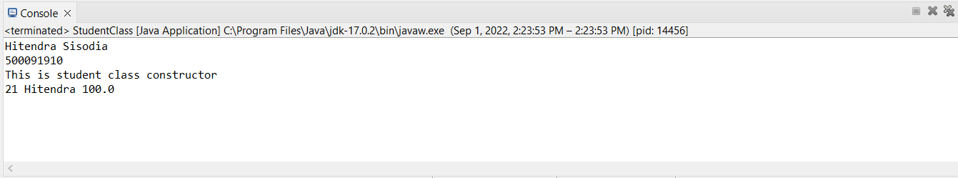

Ques2: Write a program in JAVA to show the use of ‘this’ keyword when parameters and instance variables are the same.

Source Code

**package** Lab4;

**class** Student1

{

**int** rollno;

String name;

**float** marks;

Student1(**int** rollno,String name,**float** marks){

//this keyword used to make sense between class instance and function arguments.

**this**.rollno = rollno;

**this**.name= name;

**this**.marks = marks;

}

**void** display() {

System.***out***.println(rollno+" "+name+" "+marks);

}

}

**public** **class** ThisDemo {

**public** **static** **void** main(String args[]) {

System.***out***.println("Hitendra Sisodia");

System.***out***.println("500091910");

Student1 s1 = **new** Student1(21,"Hitendra",99.9f);

Student1 s2 = **new** Student1(22,"Om",100f);

s1.display();

s2.display();

}

}

Output

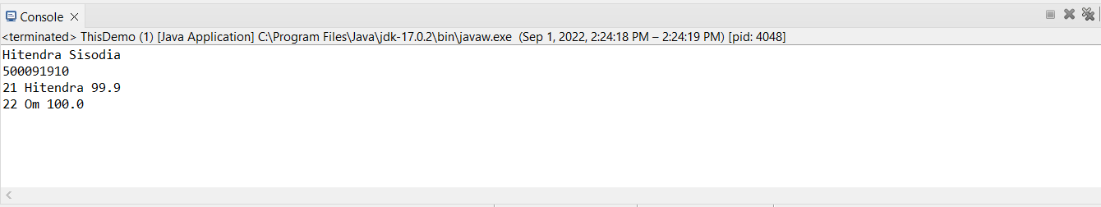

Ques3: Write a program in JAVA to implement constructor chaining. The program should enable creation of objects with three arguments (Roll_no, name, marks) and four arguments (Roll_no, name, marks, fee).

Source Code

**package** Lab4;

**class** Student2

{

**int** Roll_no;

String name;

**float** marks;

**float** fee;

// constructor 1

Student2(**int** Roll_no,String name,**float** marks){

**this**.Roll_no = Roll_no;

**this**.name = name;

**this**.marks = marks;

}

// constructor 2

Student2(**int** Roll_no,String name,**float** marks,**float** fee){

**this**(Roll_no,name,marks);

**this**.fee = fee;

}

**void** display() {

System.***out***.println(Roll_no+" "+name+" "+marks+" "+fee);

}

}

**public** **class** ConstructorChaining {

**public** **static** **void** main(String args[]) {

System.***out***.println("Hitendra Sisodia");

System.***out***.println("500091910");

Student2 s1 = **new** Student2(21,"Hitendra",99f,10000f);

Student2 s2 = **new** Student2(22,"Om",100f);

s1.display();

s2.display();

}

}

Output

